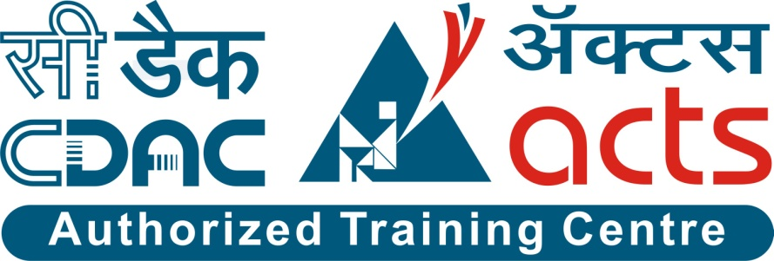

Project Name:

“Evento - Event Management System”

Branch E-DAC Sept- 2021.

Documentation On:

“Evento - Event Management System”

E-DAC Sept 2021

**Guided By: Bakul Joshi**

Submitted By :

**Group No: 02**

* **Dinesh Parate 210943020020**
* **Akash Kadam 210943020005**
* **Rohan Shirsat 210943020072**
* **Shailesh Sarode 210943020083**

**Table of Contents**

**1. Introduction 4**

1.1 Document Purpose **4**

1.2 Project Background **4**

1.3 Aim & Objectives **4**

**2. Business Requirements Overview**…………………………………………………………**5**

**3.Functional Requirements** **5**

3.1 Customer Module **5**

3.2 Vendor Module **6**

3.3 Admin Module **6**

**4.** **Non-Functional Requirement………………………………………………………………6**

**5. Use Case Diagram 7**

5.1 Customer **7**

5.2 Vendor **8**

5.3 Admin **9**

**6. Database Design 10**

1 Login **10**

2 Questions **10**

3 Customers… …………………………………………………………………………… **10**

4 Events **11**

5 Services **11**

6 Event Services **11**

7 Event Requests **11**

**7. E-R Diagram…………………………………… ……………………………………12**

**8. Snapshots 13**

**9. Conclusion 25**

**List of Figures**

**Use Case Diagrams 7**

Fig 1 Customer 7

Fig 2 Vendor 8

Fig 3 Admin 9

Fig 4 ER Diagram 12

1. **Introduction:**

**Document Purpose:**

This document explains the system requirements and scope for developing Online Event Management System. Online Event Management System could divide the four main parts, Customer part, Vendor part, Admin part and the acknowledgement part.

This document communicates the business requirements and scope for developing Event Management System. The scope of this document is to define the functional and non functional requirements, business rules and other constraints requirements.

## Project Background:

Organizing the event needs variety of services from different vendors like decoration ,Catering etc….There is no system available currently which provides a common platform for searching the different vendors required for various services for a particular event Currently customer ,corporate companies visit to nearest vendor who provides services such as decoration, catering, photography etc. for booking their services for their event if one of them vendor is already booked by someone else then searching another vendor for event is time consuming and tedious task for customers and corporate companies.

## Aim & Objectives:

The main objective of the system is to build an event management web Application to help customers , corporate companies to arrange their events like Birthday ,wedding. Training. This web application is useful to save lot of efforts , time , resources of customers. Addition on it this system collaborate with the local vendors who provides services for events. it will help the vendors to get various orders through system and it results to grow their business .

**Business Requirements Overview**

* Event management System is the public web application.
* Event management System will be opened to the local, but in the phase 1st, the main target is in the pune.
* There are mainly three types of user. One is the customer , second one is Vendor and third is admin.
* Small vendor can upload services details on system.
* Customer can manage the event by giving more the details about the event through the system confirm different event.
* Admin manages all the events.

1. **Functional Requirements Overview**

Event Management System consists of three modules described as below.

* Customer Module
* Vendor Module
* Admin Module
* **3.1 Customer Module**
* Customer can browse the all events and the detailed services which provided by the system.
* Customer can register to the system.
* Customer can submit the details of event and their requirements with budget to the system.
* Customer can receive the approval of event notification by the admin .
* Customer can view the successful event stories through event gallery from the system.
* **3.2 Vendor Module**
* Vendor can login to the system.
* vendor can upload their services in the system.
* vendor can receive the detailed requirement of event through the system.
* vendor can view the successful event stories through event gallery from the system.
* **3.3 Admin Module**
* Admin can view the details of customers and their event requirement.
* Admin can view the details of vendors and their services.
* Admin can confirm and cancel the event request raised by customer.
* Admin can add or remove the vendors in the system.
* Admin send event confirmation notification to the customer.

1. **Non-functional Requirements**

* The website should use professional design, look and feel and colour scheme.
* Users will have no limitations for accessing the application through Internet. The portal being an internet application, it is difficult specify exact number of visitor or users. Hence we will target the system to support between 5 and 10 million users on launch of phase 1.
* Being a public website, the site must follow general usability guidelines for menus, navigation, colors, links and other actions provided on the screens.
* The system should be designed in such a manner that user will be able to complete tasks in minimum number of steps.

## 5. Use-Case Diagram

**5.1 Customer:**

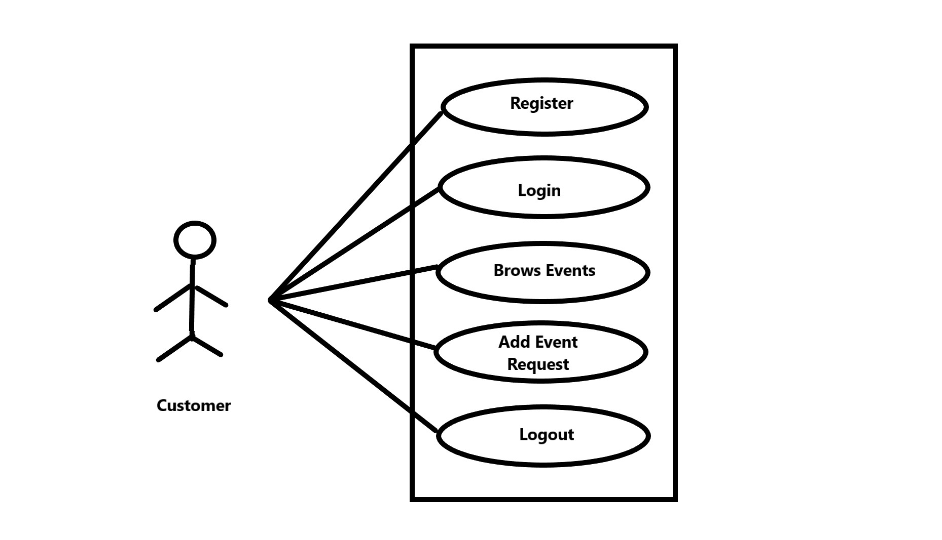

Fig. Use-Case Diagram for Customer

## 5.2 Vendor:

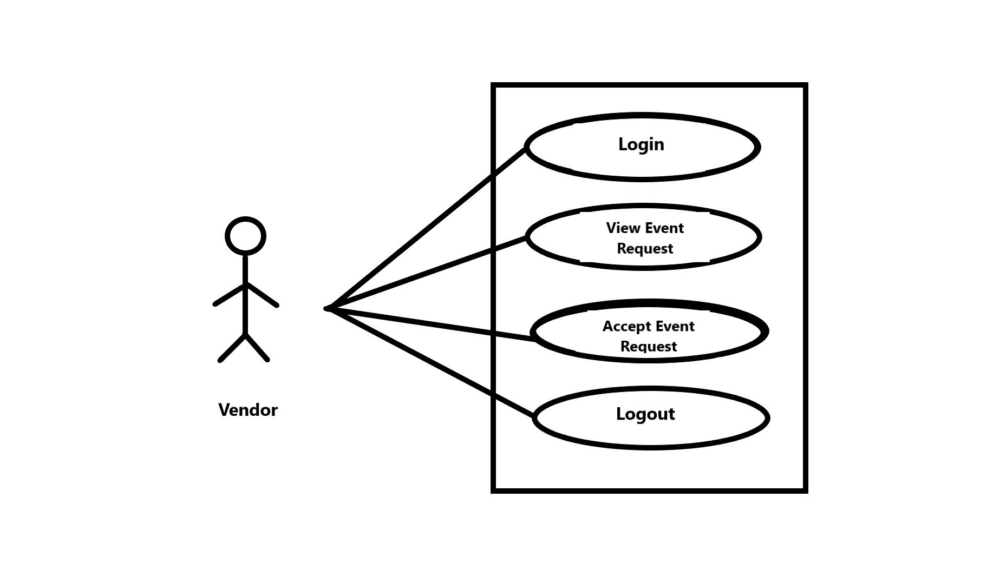

Fig. Use-Case Diagram for Vendor

**5.3 Admin:**

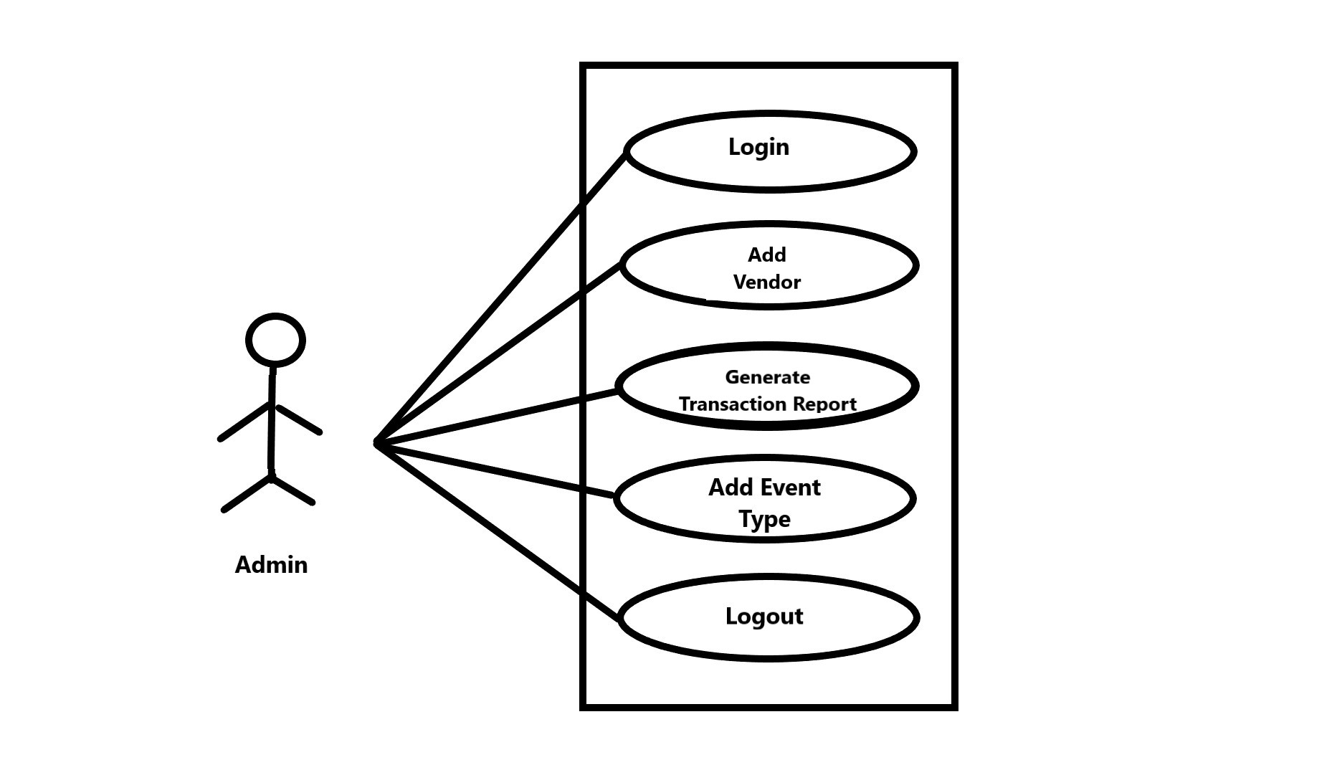

Fig. Use-Case Diagram for Admin

**6. Database Design:**

1] Login

|  |  |  |  |  |  |
| --- | --- | --- | --- | --- | --- |
| **Field** | **Type** | **Null** | **Key** | **Default** | **Description** |
| Login_id | Int | No | Primary Key |  | Login ID |
| Emailid | Varchar (45) | No |  |  | Email of users |
| Password | Varchar (12) | No |  |  | Password |
| Role | Varchar (12) | No |  |  | Role |
| Security_Ans | Varchar (255) | No |  |  | Security Answer |
| Sec_id | Int | No | Foreign key |  | Security Question ID |

2] Questions

|  |  |  |  |  |  |
| --- | --- | --- | --- | --- | --- |
| **Field** | **Type** | **Null** | **Key** | **Default** | **Description** |
| Sec_id | int | No | Primary key |  | Question ID |
| Sec_Question | Varchar (255) | No |  |  | Security question |

3] Customers

|  |  |  |  |  |  |
| --- | --- | --- | --- | --- | --- |
| **Field** | **Type** | **Null** | **Key** | **Default** | **Description** |
| Custid | Int | No | Primary key |  | Customer ID |
| Fname | Varchar (10) | No |  |  | Customer First name |
| Lname | Varchar (10) | No |  |  | Customer last name |
| contactNo | Varchar (12) | No |  |  | Customer contact number |
| Email | Varchar (45) | No |  |  | Customer Email |
| Address | Varchar (255) | No |  |  | Customer Address |
| Loginid | Int | No | Foreign key |  | Login ID |

4] Vendors

|  |  |  |  |  |  |
| --- | --- | --- | --- | --- | --- |
| **Field** | **Type** | **Null** | **Key** | **Default** | **Description** |
| Vid | Int | No | Primary key |  | Vendor ID |
| VendorName | Varchar (10) | No |  |  | Vendor name |
| BusinessName | Varchar (10) | No |  |  | Vendor Business/ organization name |
| contactNo | Varchar (12) | No |  |  | Vendor contact number |
| Email | Varchar (45) | No |  |  | Vendor Email |
| Address | Varchar (255) | No |  |  | Vendor Address |
| Loginid | Int | No | Foreign key |  | Login ID |

5] Events

|  |  |  |  |  |  |
| --- | --- | --- | --- | --- | --- |
| **Field** | **Type** | **Null** | **Key** | **Default** | **Description** |
| Eid | Int | No | Primary Key |  | Event ID |
| Ename | Varchar (45) | No |  |  | Event Name |
| Description | Varchar (255) | No |  |  | Description about event |
| Price | Decimal (7,2) | No |  |  | Base price of event |
| AddOnPrice | Decimal (7,2) | No |  |  | Add on price of event |

6] Services

|  |  |  |  |  |  |
| --- | --- | --- | --- | --- | --- |
| **Field** | **Type** | **Null** | **Key** | **Default** | **Description** |
| Sid | Int | No | Primary Key |  | Service ID |
| Sname | Varchar (45) | No |  |  | Service name |
| Description | Varchar (255) | No |  |  | Description about service |

7] Event Service

|  |  |  |  |  |  |
| --- | --- | --- | --- | --- | --- |
| **Field** | **Type** | **Null** | **Key** | **Default** | **Description** |
| Eid | Int | No | Composite Key | Null | Event ID |
| Sid | Int | NO |  | Null | Service ID |

8] Event Requests

|  |  |  |  |  |  |
| --- | --- | --- | --- | --- | --- |
| **Field** | **Type** | **Null** | **Key** | **Default** | **Description** |
| Reqid | Int | No | Primary Key |  | Request ID |
| Location | Varchar (45) | No |  |  | Location of Event |
| DateAndTime | Date | No |  |  | Event Date and Time |
| NoOfGuest | Int | No |  |  | Number of Guest |
| Budget | Decimal (7,2) | No |  |  | Budget of Customer |
| Status | Varchar (45) | No |  |  | Request Status |
| Eid | Int | No | Foreign Key |  | Event ID |
| Vid | Int | Yes | Foreign Key | Null | Vendor ID |
| Custid | Int | No | Foreign Key |  | Customer ID |

## 7. ER-Diagram:

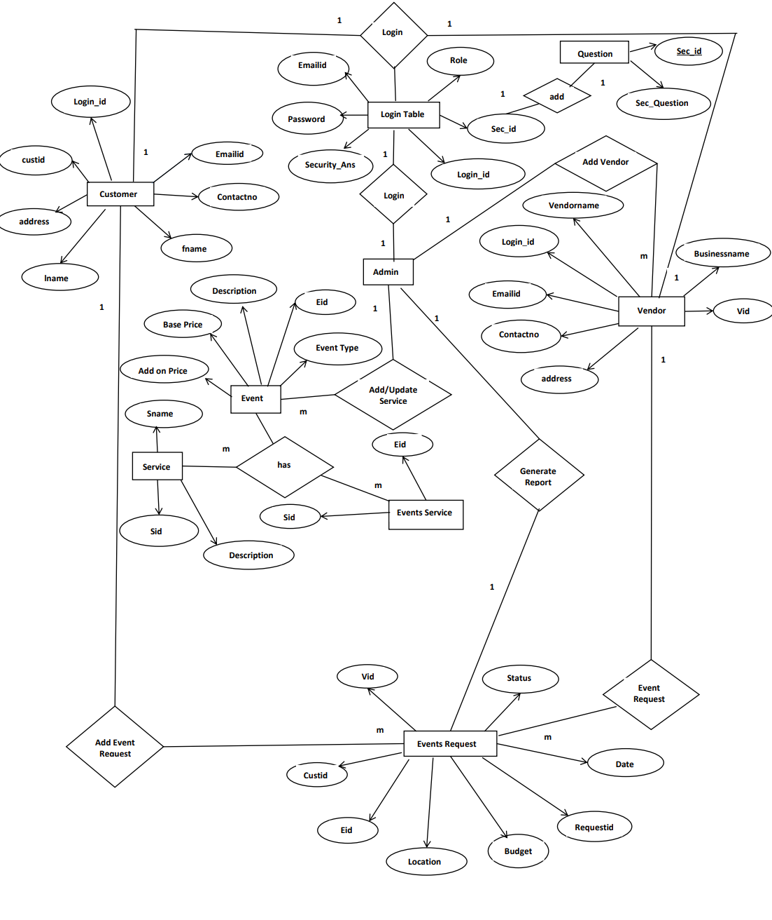

**E-R diagram shows database of Online Event Management System.**

**8. Snapshots:**

**8.1 Home Page:**

Following snapshot shows the Home page for Online Car And Bike Rental System

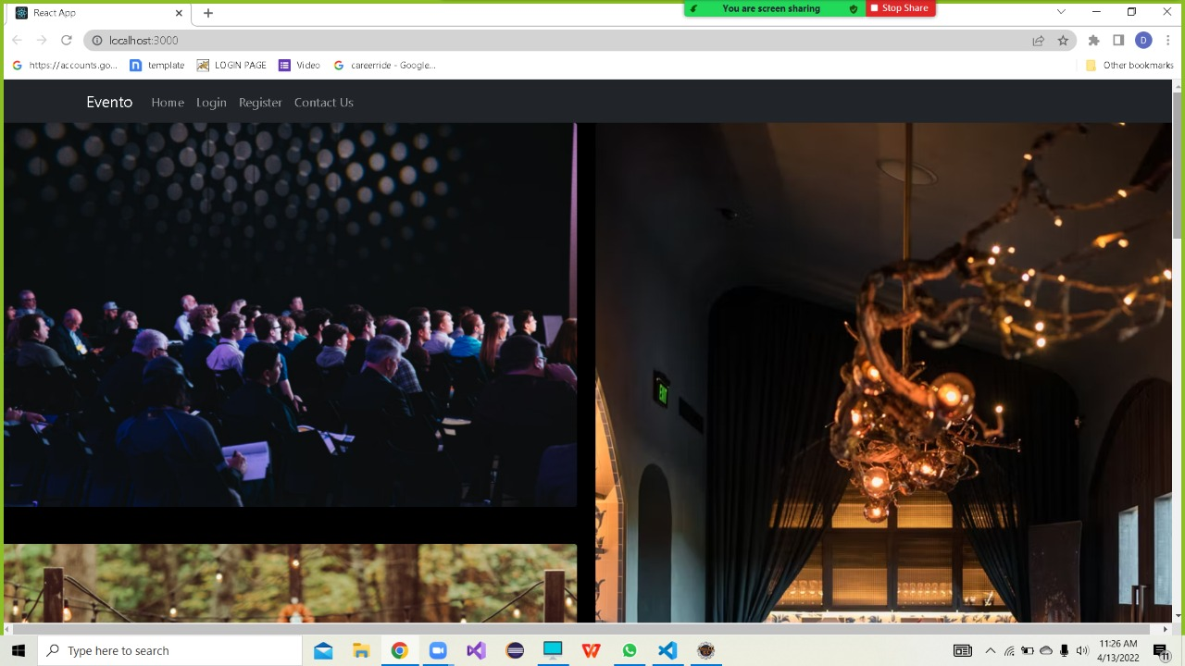

This page contains following controls

* Home
* Login
* Register
* Contact Us

**8.2 Contact And About Page**

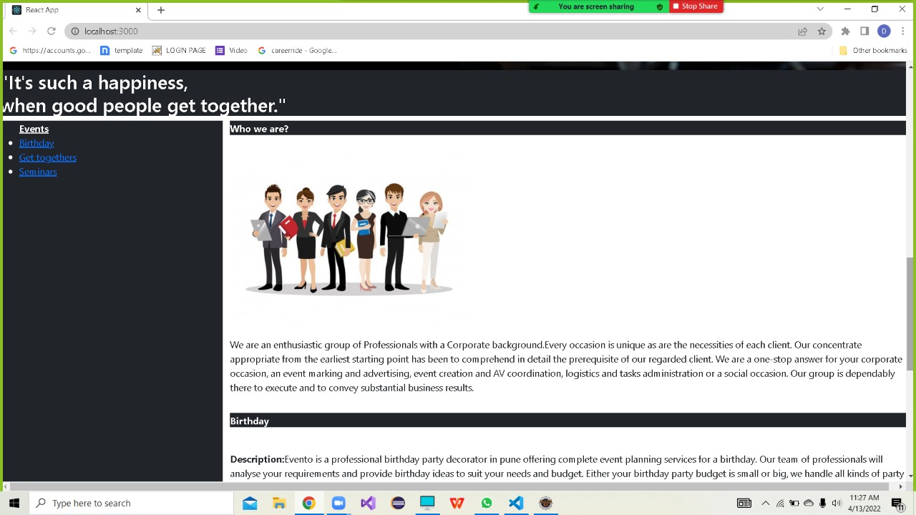

**8.3 Login Page**

Following snapshot shows the Login page for Online Car And Bike Rental System

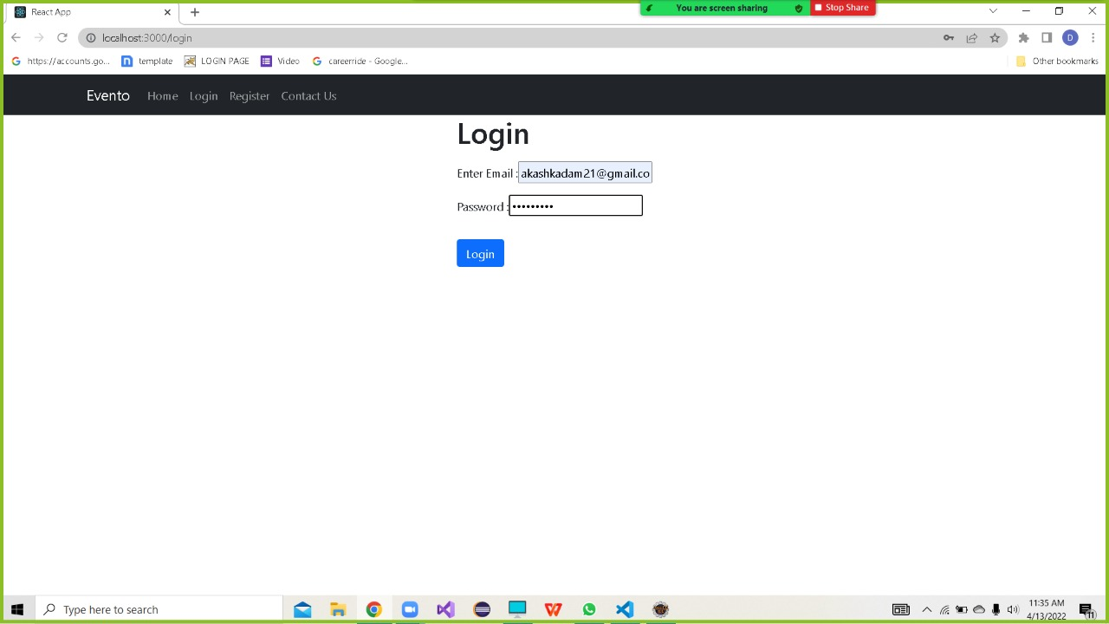

**8.4 Customer Registration Page**

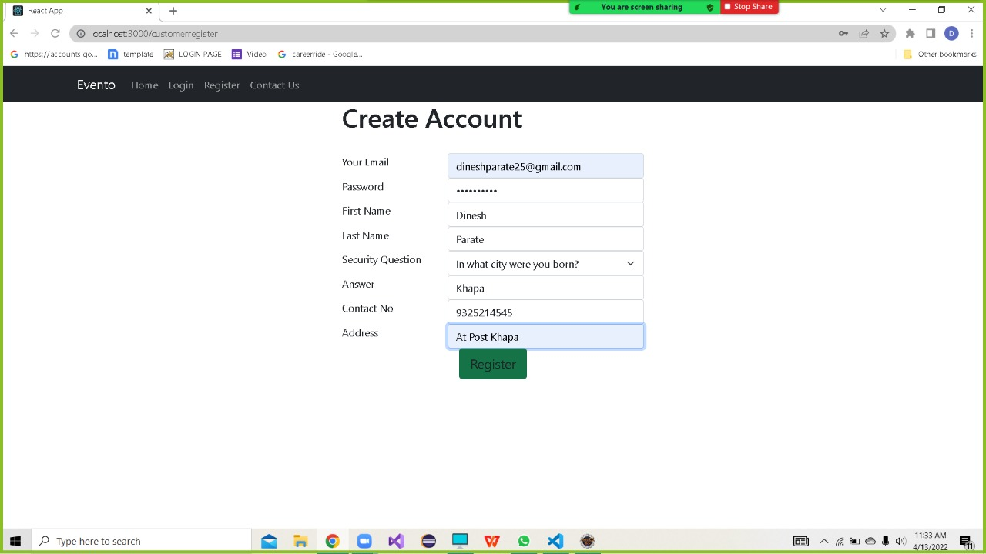

**8.5 Contactus Page for Vendor**

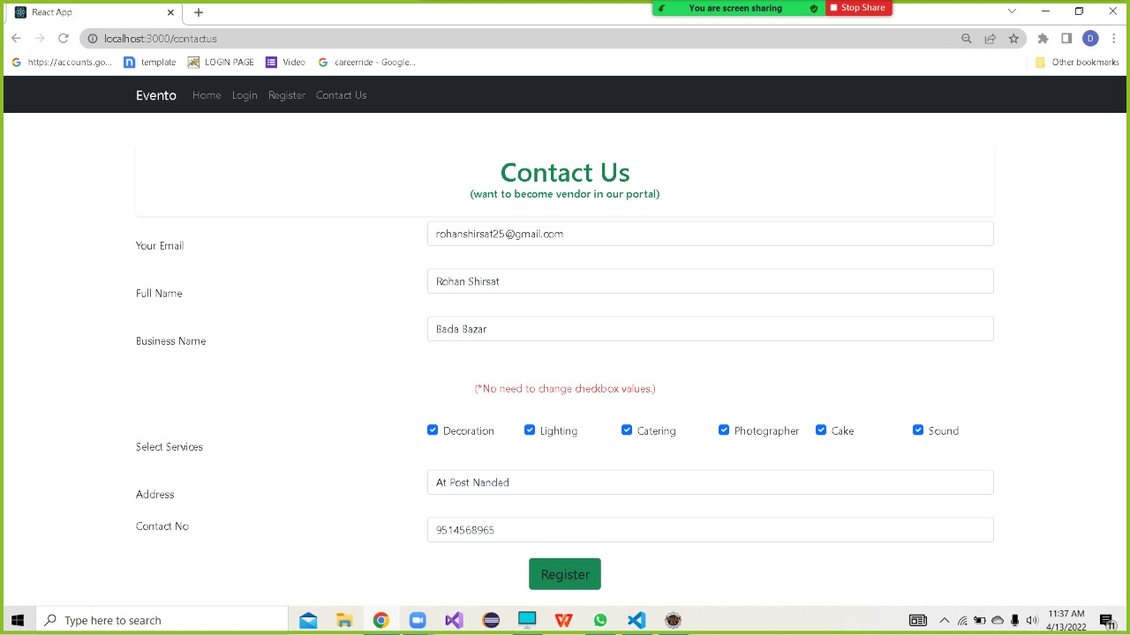

**8.7 Customer Page**

**8.7.1 Add Event Request Page**

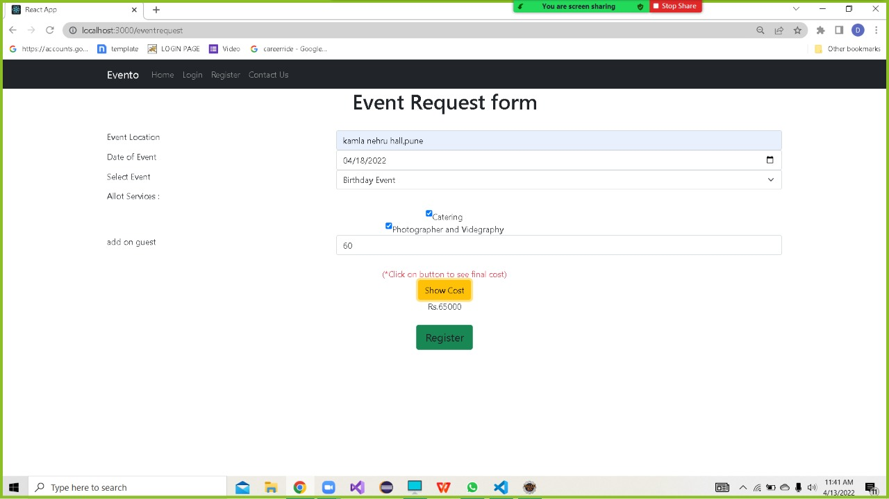

**8.7.2 Customer Update Profile Page**

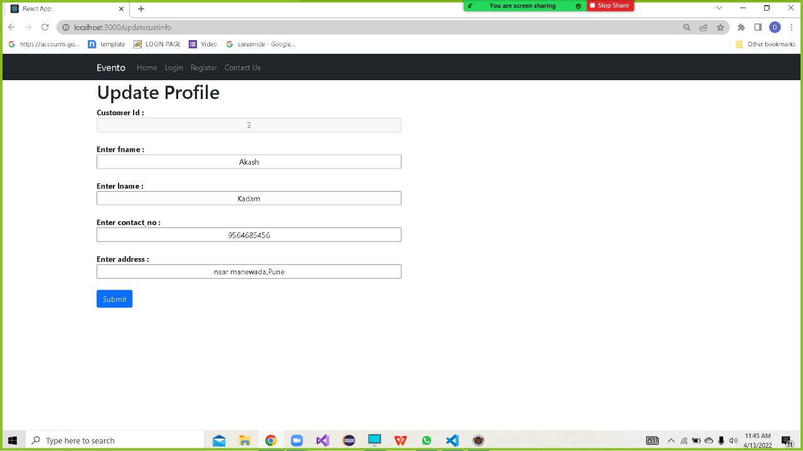

**8.8 Vendor Page**

**8.8.1 Vendor Accept Event Request Page**

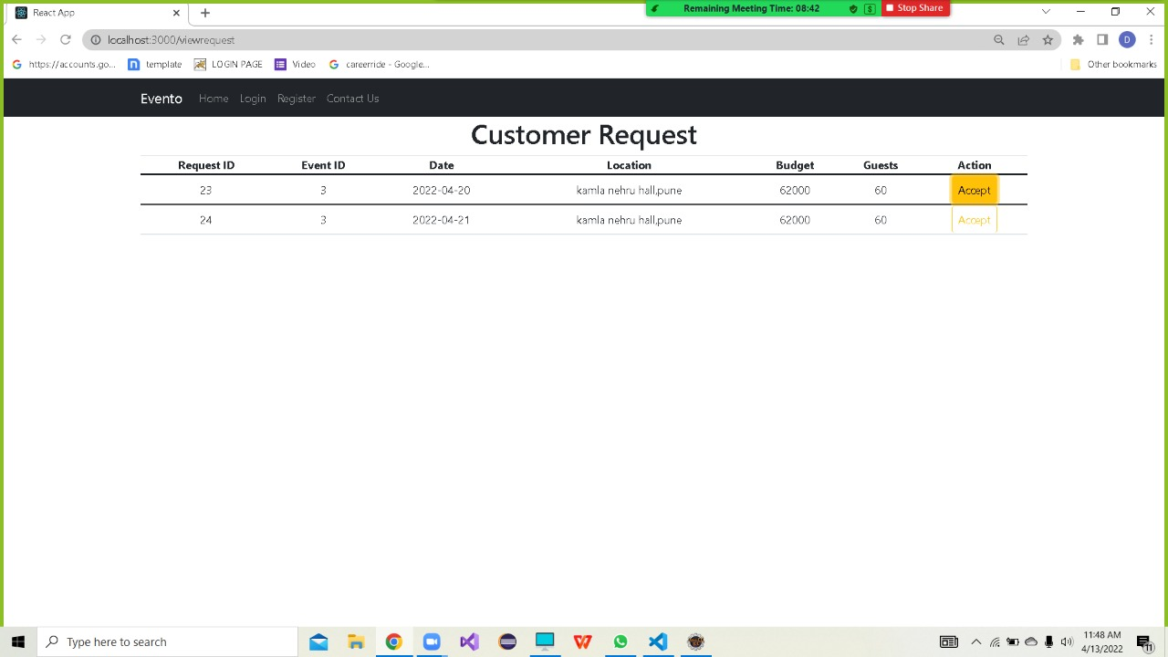

**8.8.2 Vendor Update Profile Page**

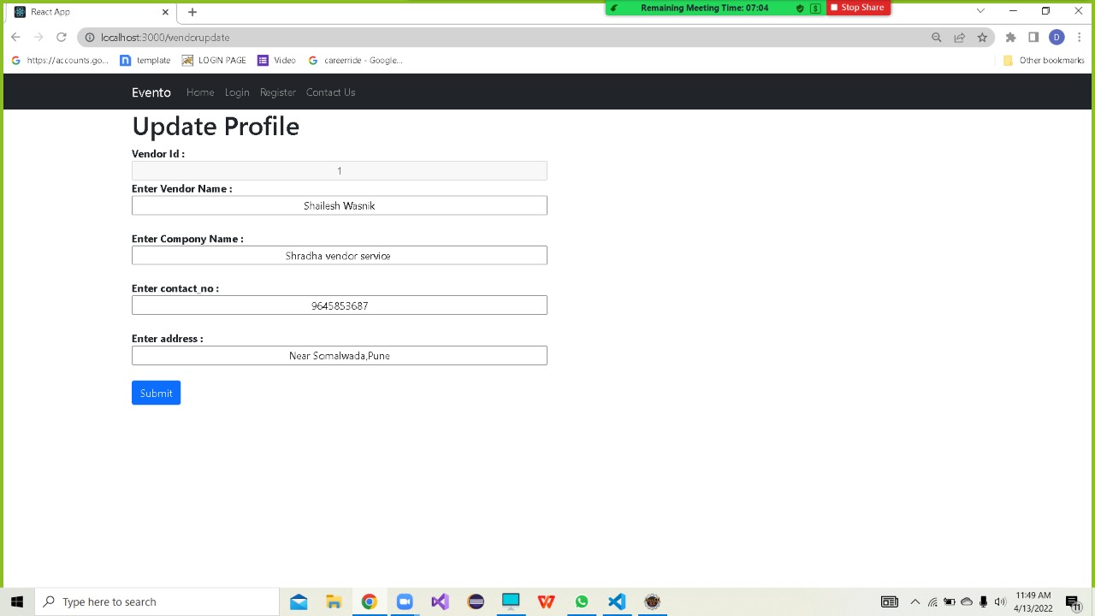

**8.9 Admin Page**

**8.9.1 Add Events Page**

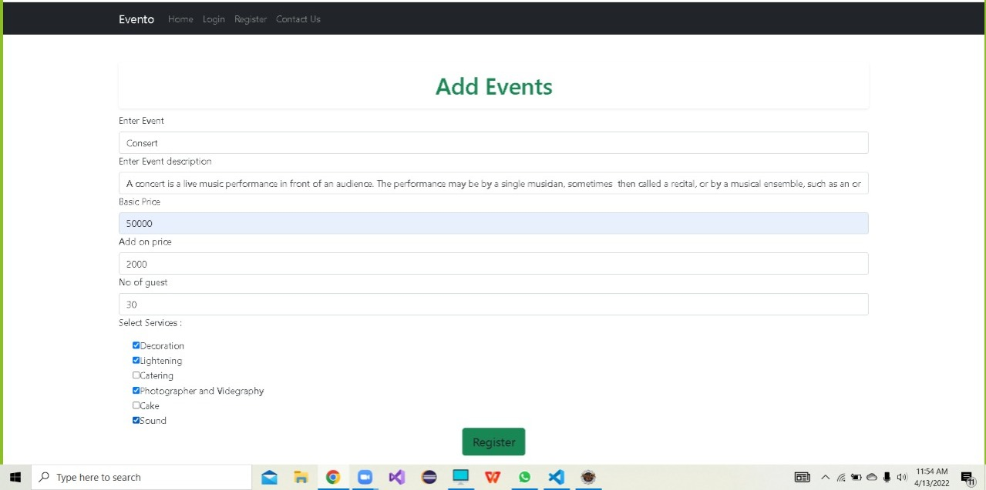

**8.9.2 Vendor Registration Page**

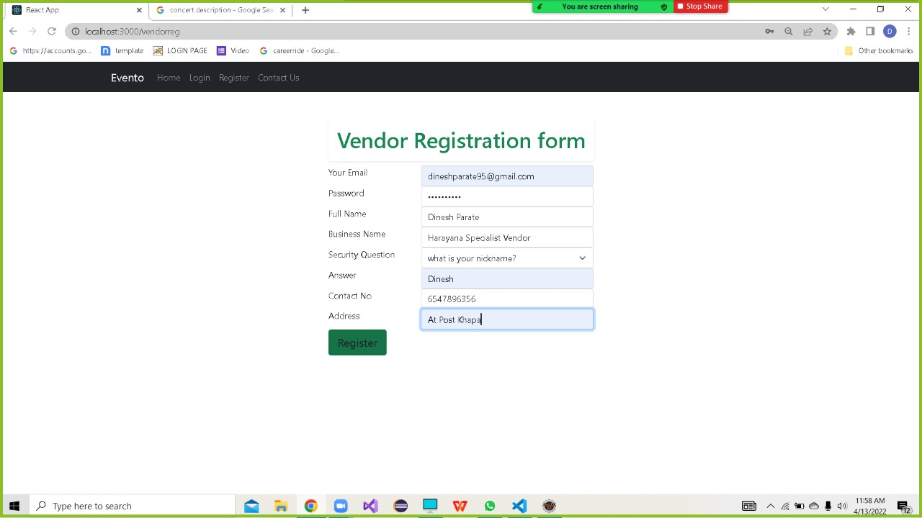

**8.9.3 Reports Generation Page**

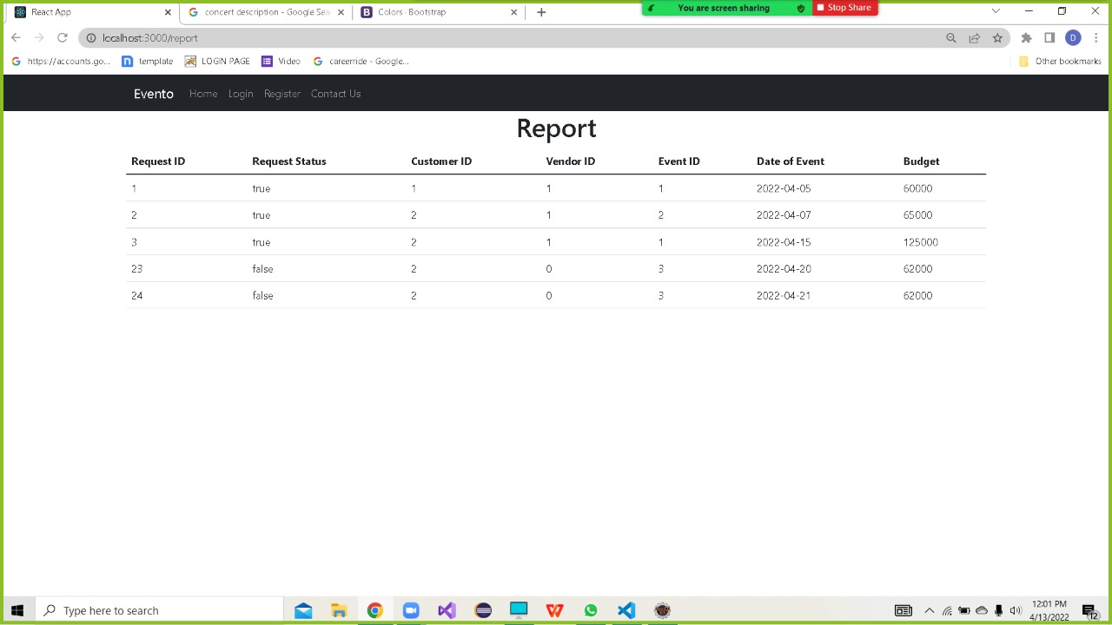

**9. CONCLUSION**

Currently, this system works on the one vendor policy where one vendor should be provide all the required services of event In future extension we will allow different vendors to provide different services for single event .Uptil now we conduct one event per day so in future we will allow to organise multiple events per day .Also now our system is works only within pune city so in future we will work in different cities.

Event Management System is user friendly and cost effective system. It provides a new edge to management industry. Evento always keep your objectives and goals on top priority while conducting the events.Event management System provides better management of event to customer and local vendors get the business from our system.